Objectives Achieved
- Understood how local, global, and formal parameter scopes differ.
- Practiced writing custom functions with multiple arguments.
- Observed how global variables interact with function parameters.
- Applied mathematical formula implementation using functions.
Task 1 — Complete sum_of_prod()
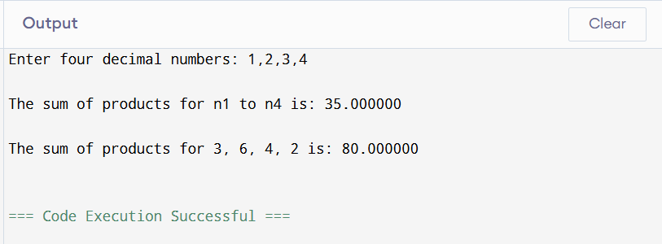
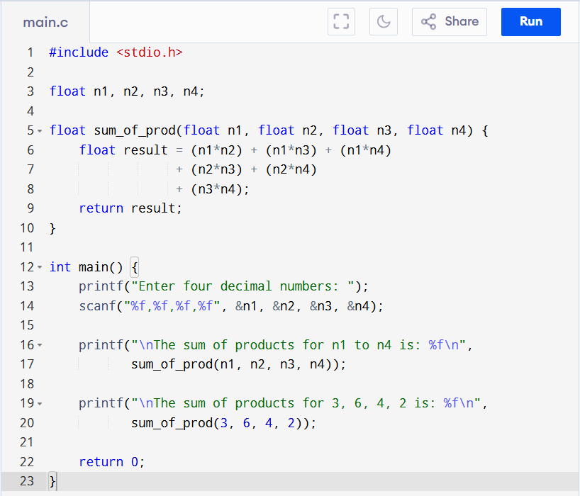
Program code
Conclusion (Task 1)
This task showed:
- Formal parameters override global variables inside functions.
- The function scope uses local copies of provided arguments.
- Global variables remain unchanged unless explicitly modified.

Task 2 — Compute y = f₁[n] + f₂[n]
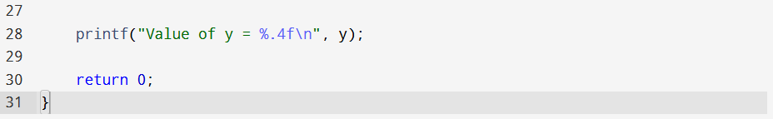
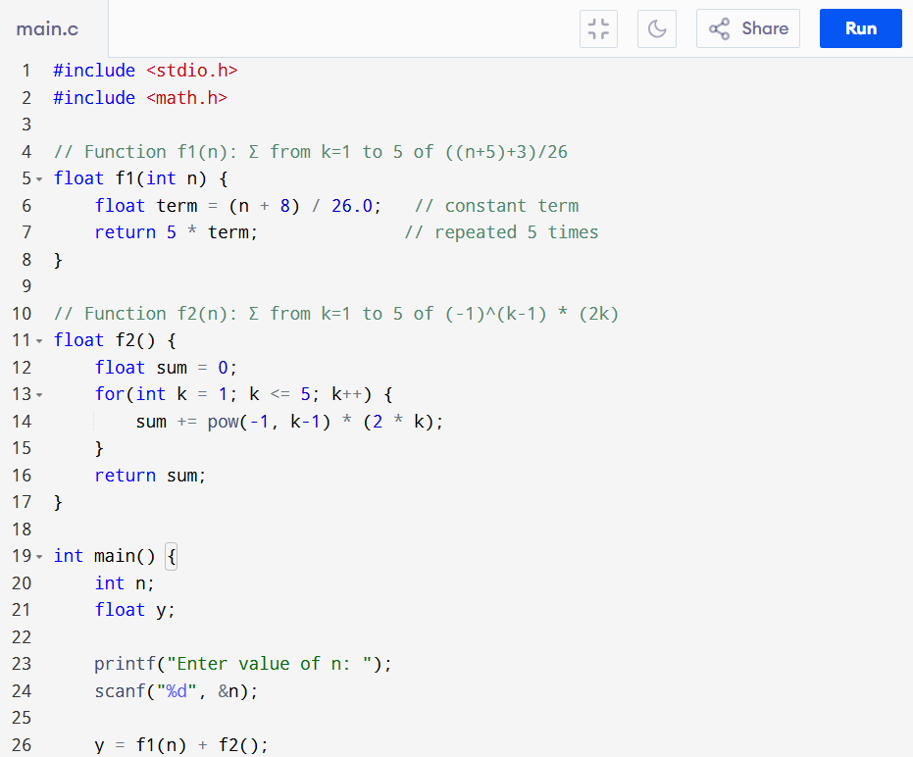
program code
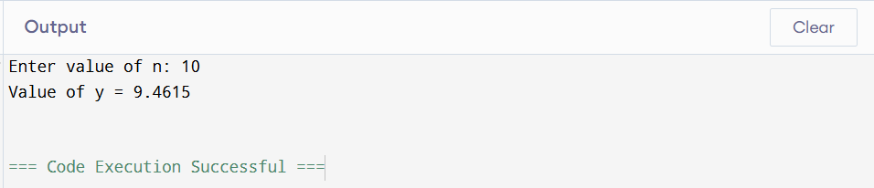

Conclusion (Task 2)
This task tested understanding of:
- Iterative evaluation of mathematical series
- Using separate functions to organize computations
- Passing arguments and interpreting return values correctly

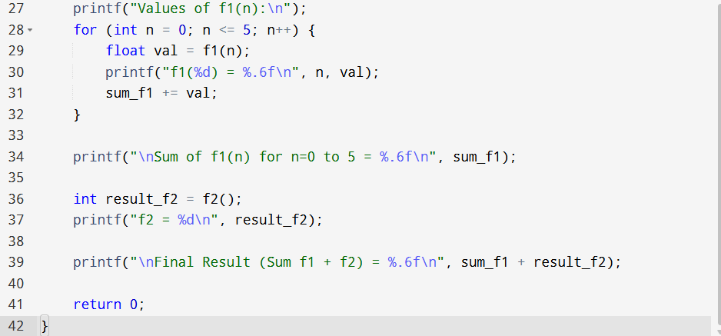
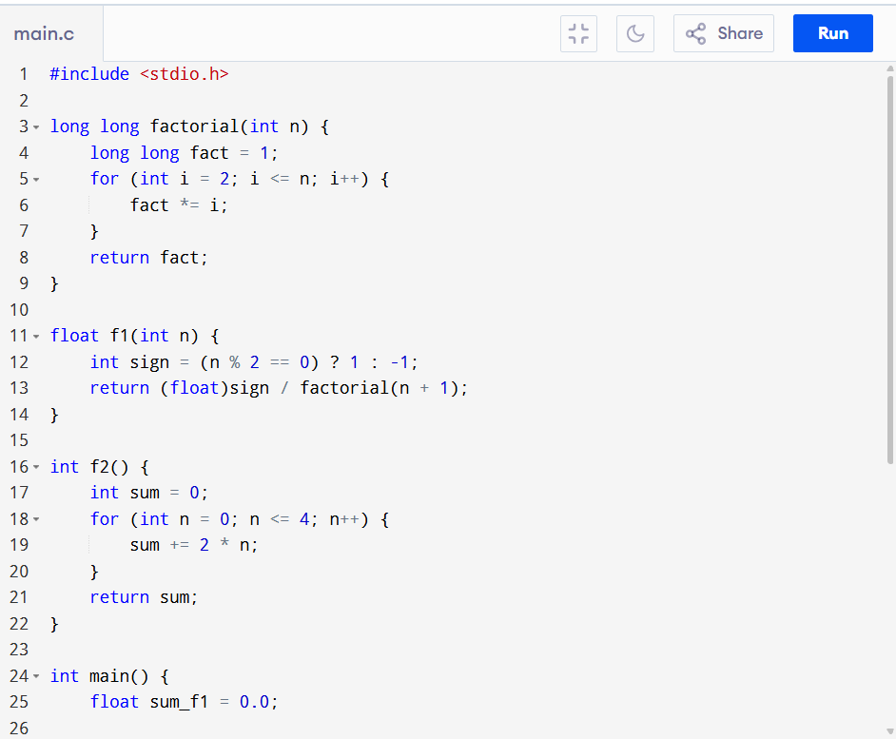
Post-Lab Task
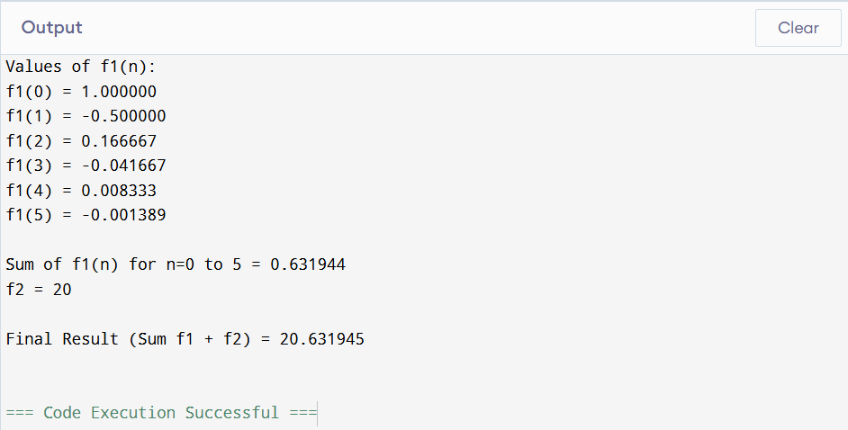
Critical Analysis (Lab 7)
This lab clarifies how variable scope affects program behaviour. It highlights that:
- Local variables override global ones inside functions.
- Formal parameters act like local variables.
- Functions modularize mathematical logic effectively.
The series calculations required careful handling of exponents and factorials, reinforcing mathematical programming competence.

